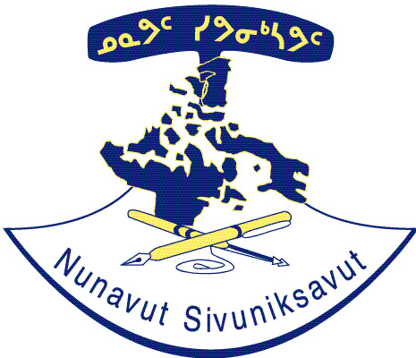
Nunavut Sivuniksavut

Climate Change and Inuit

Date of ethics clearance: March 8th, 2016

Anny Chislett, chislettanny@gmail.com, Advanced Inuit Studies, Nunavut Sivuniksavut

Samantha Mitchell, Nunavut Sivuniksavut (613-244-4937 ext 17) Email: s.mitche08@gmail.com

- Purpose of Study: This research project will focus on climate change in the Canadian North. Attention will be paid to affects on Inuit way of life.
- Procedures and Duration: You will be asked to participate in a semi-structured interview. This can take 20-30 minutes to complete, depending on your knowledge and interest in the topic.
- Benefits: You will be given the change to speak of climate change. With this in mind, you may learn something new about this in talking about it with the researcher.
- Statement of anonymity: Your participation in this research is strictly anonymous. The only identifying information that is asked for is on this consent form, and it will in no wat be linked to the data collected in your interview. The interview itself does not require any information that could identify who the responses belong to.
- Right to ask questions: If you have any questions about this interview or research project, please do not hesitate to ask. I can be reached at the e-mail address above.
- Voluntary Participation: Your decision to participate in this research project is completely voluntary. Should you wish, you may stop at any time. You are under no obligation to answer questions that you do not feel comfortable answering.
- Right to Withdraw: Additionally, if at any time you wish to opt-out of the research study, you may do so. Please inform me if this is the case. However, the last day to withdraw is March 19th, 2016.

By signing this form you verify that you have read the information in this form, and consent to taje part in the research. Thank you for your cooperation.

Full name (please print):

Signature:

Date:

If you want o be informed of the results, include your email below.

E-mail Address:

